**Serverless Application deployment using S3, API Gateway, Lambda, DynamoDb**

[**https://www.youtube.com/watch?v=BFC16uM15Cg&t=204s**](https://www.youtube.com/watch?v=BFC16uM15Cg&t=204s)

**Upoad the file aws-backend-creation-cftemplate.yml**

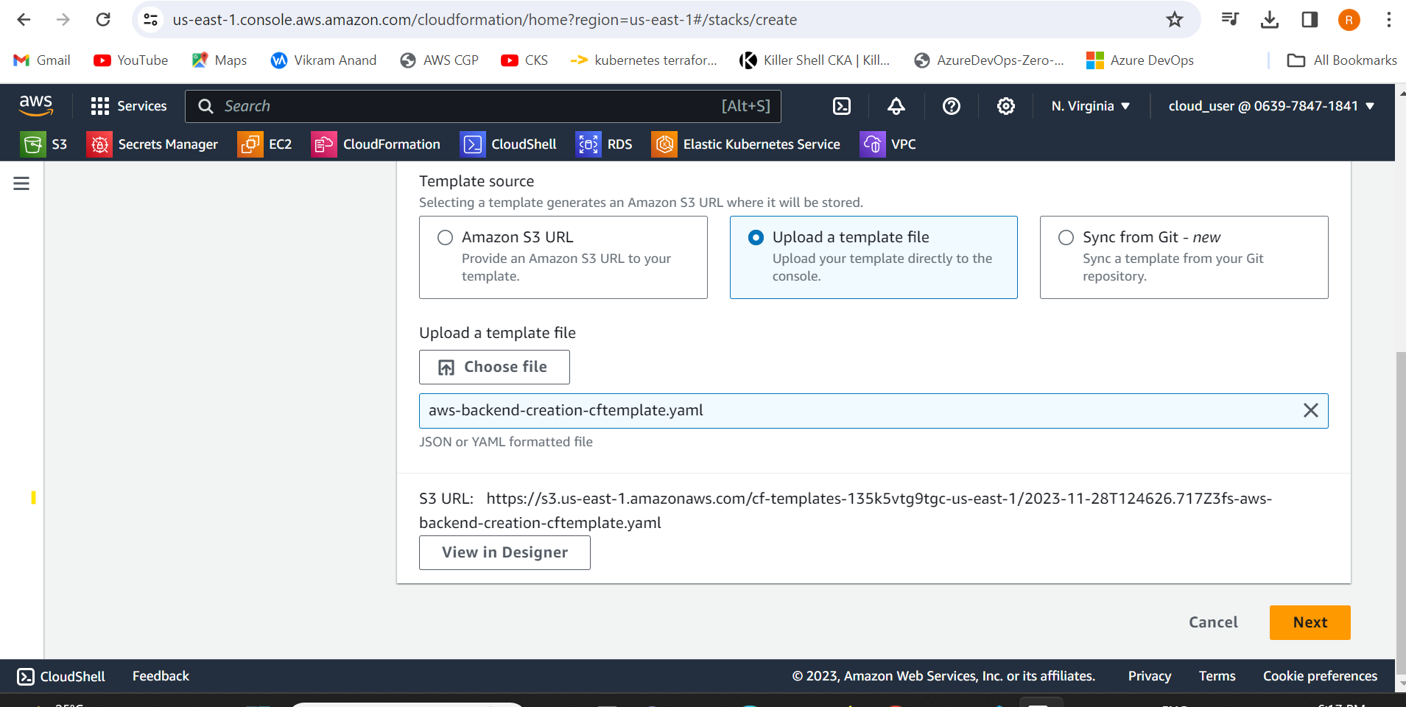

Click the view designer and then we need to create the stack

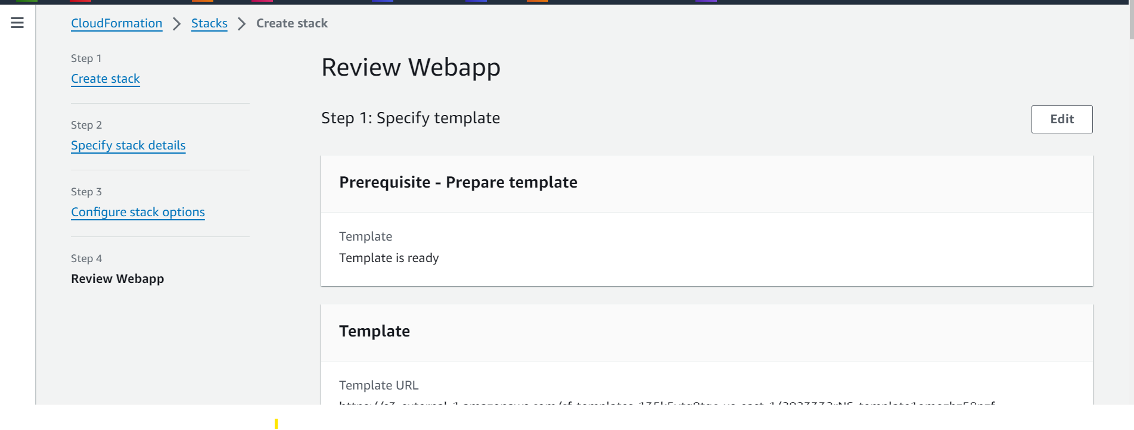

We would be able to see the ccreation of resources

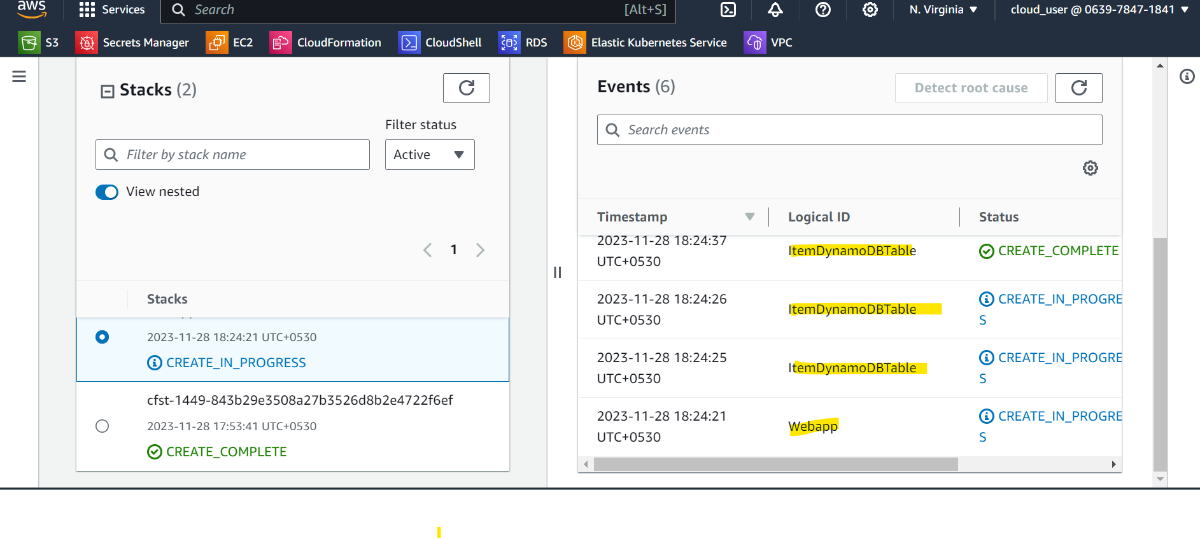

We got an error as he nodejs12x is no longer supported.

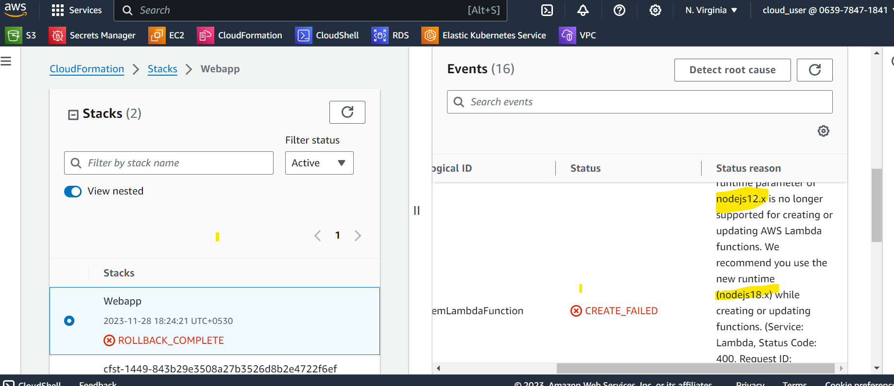

Lambda unction got created

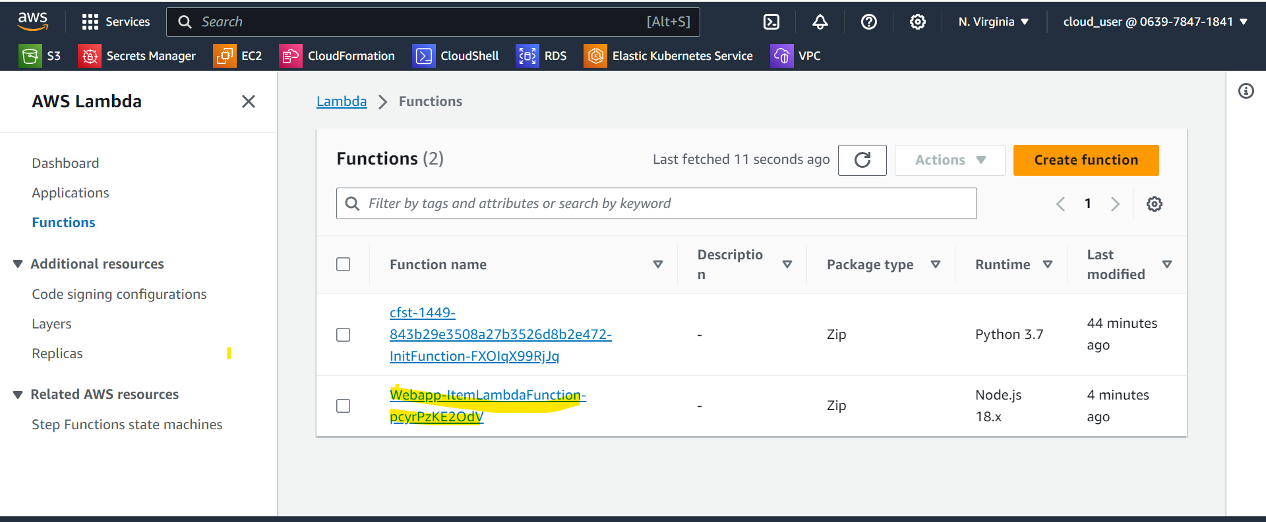

API Gateway

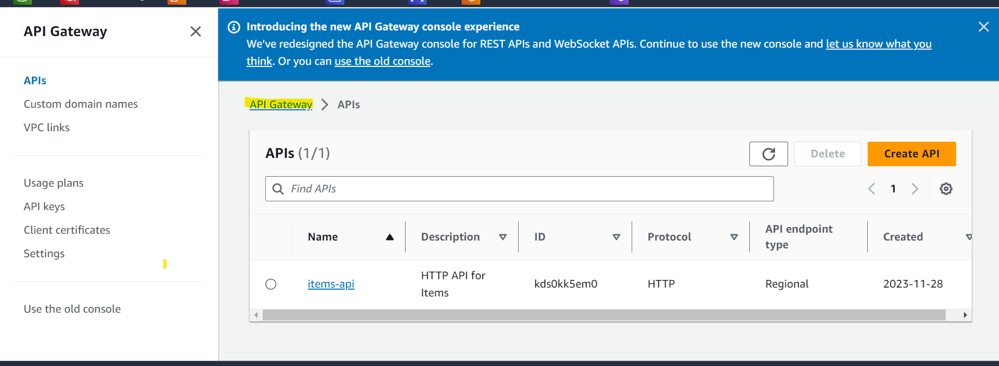

Dynamodb

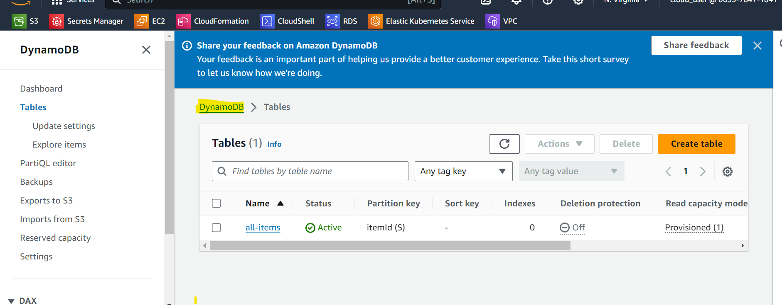

Now that we created API Gateway, Lambda function and Dynaodb table

We will now create s3 bucket to host our static website . we will enable bucket policy and CORS.

Bucket name = item-frontend-static-hosting-4545

Enable the static website hosting

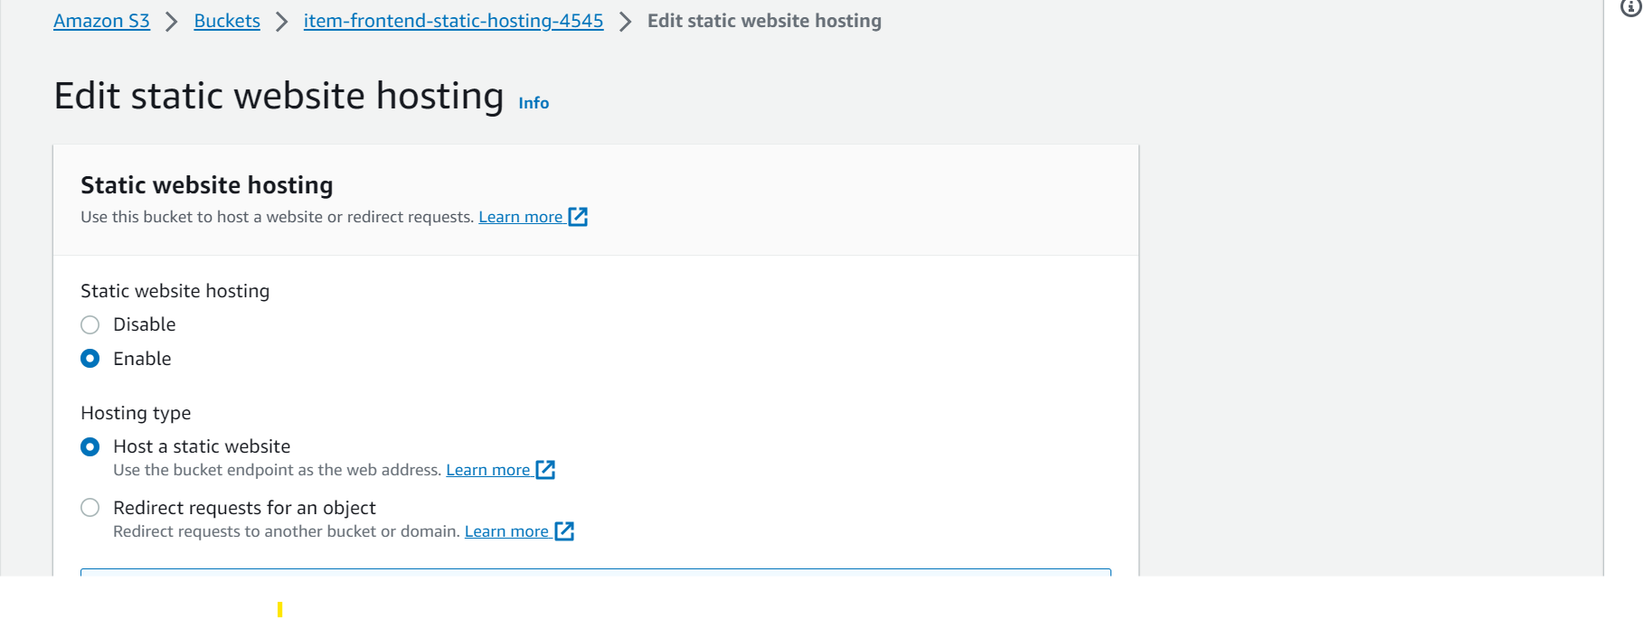

Now we change the bucket policy

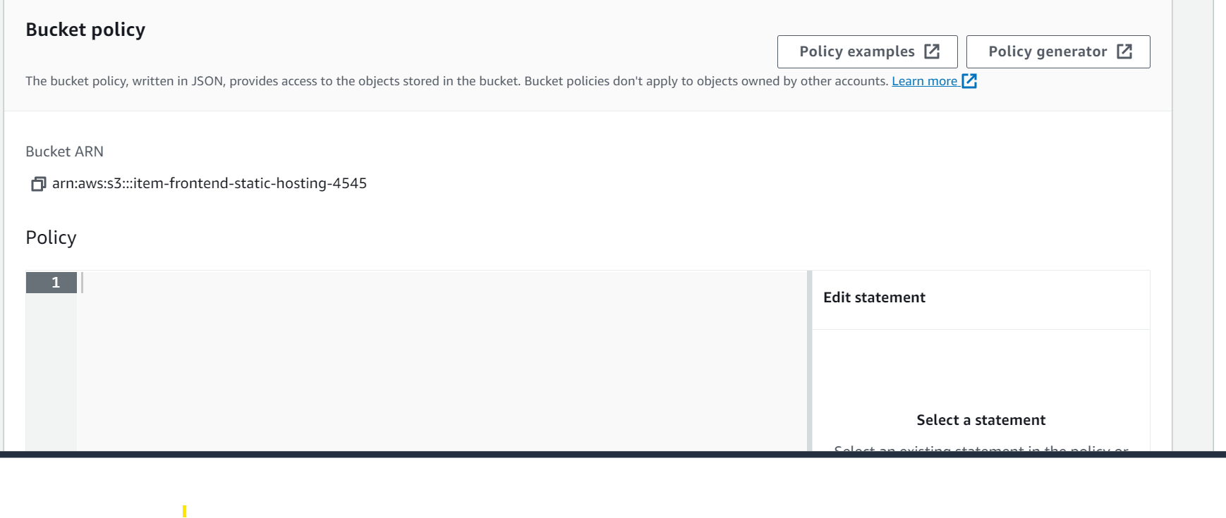

Bucket policy :

{

    "Version": "2012-10-17",

    "Statement": [

        {

            "Sid": "PublicReadGetObject",

            "Effect": "Allow",

            "Principal": "*",

            "Action": "s3:GetObject",

            "Resource": "arn:aws:s3:::items-frontend-static-hosting/*"

        }

    ]

}

Make sure to edit the bucket ARN

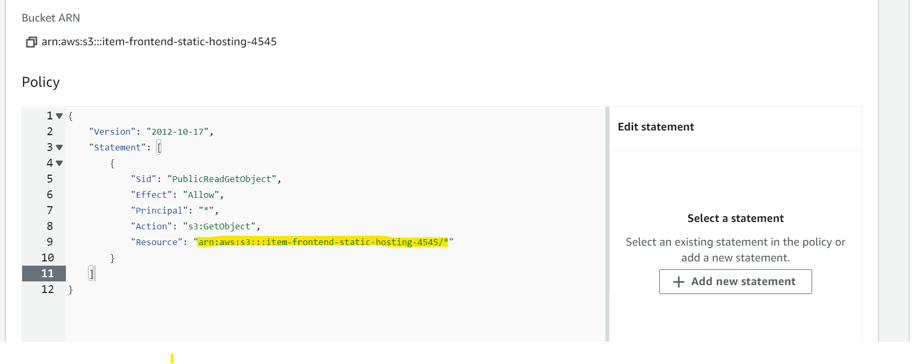

Next we enable CORS with policy:

[

{

"AllowedHeaders": [

"*"

],

"AllowedMethods": [

"GET"

],

"AllowedOrigins": [

"*"

],

"ExposeHeaders": []

}

]

Next we make changes in API gateway already created by the cloudformation stack

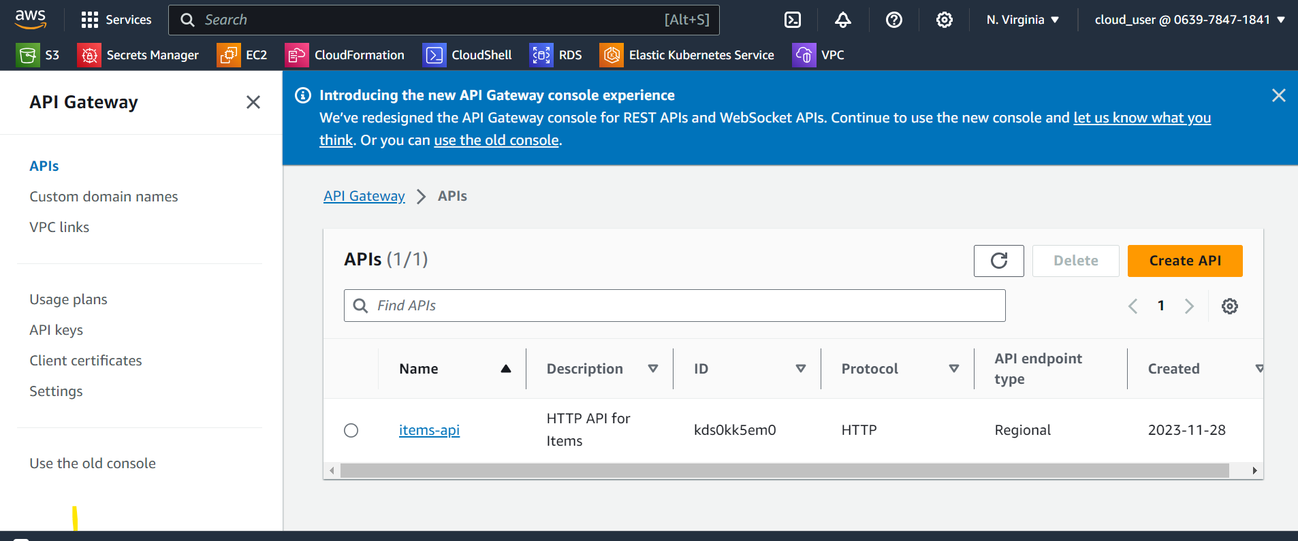

We then create a stage in API gateway

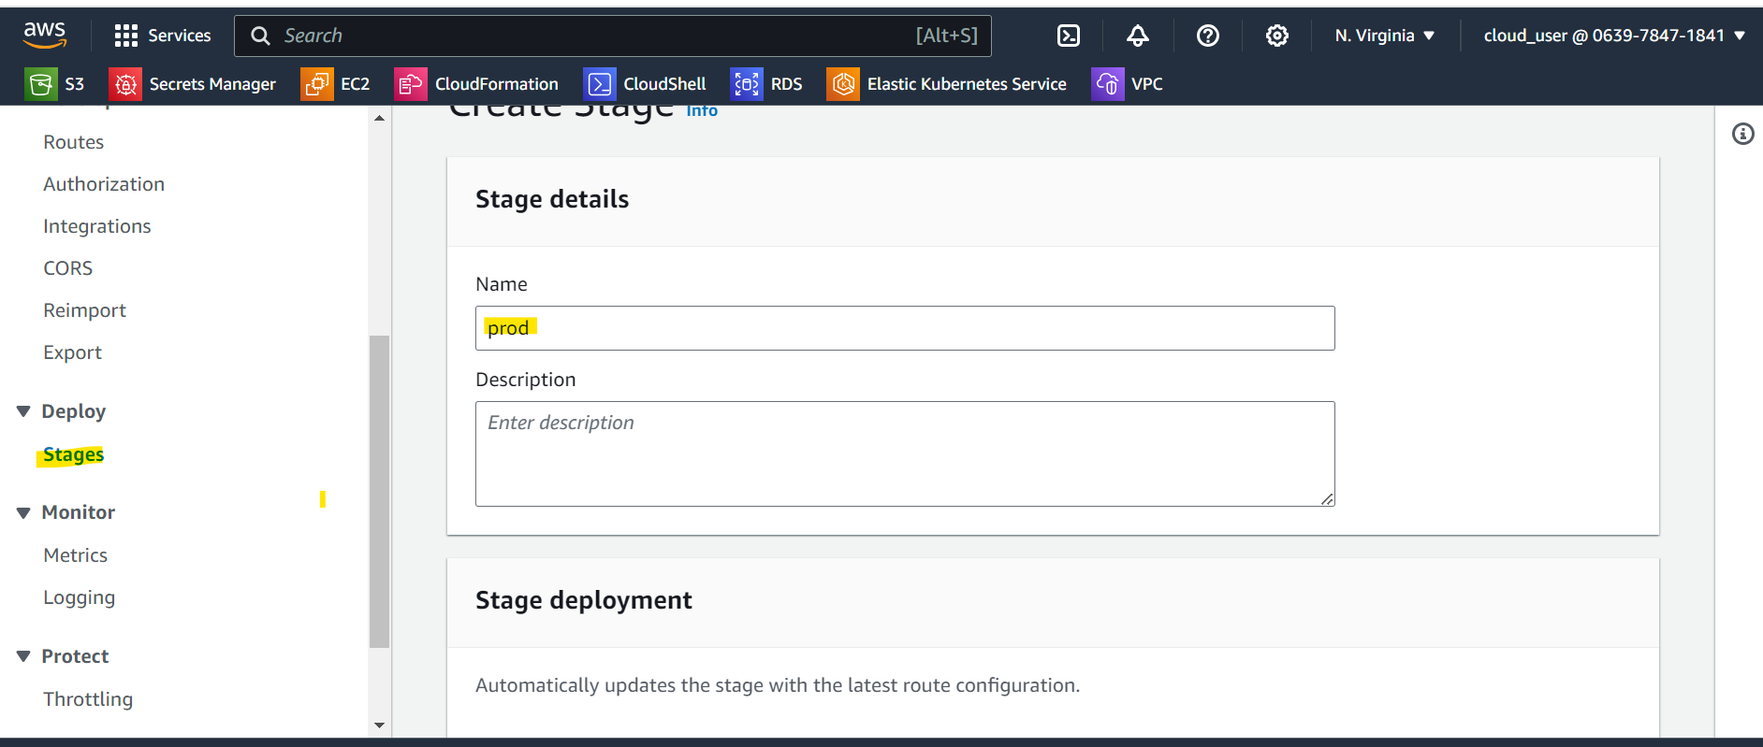

Next we go to integration and integrate with the Lambda function.

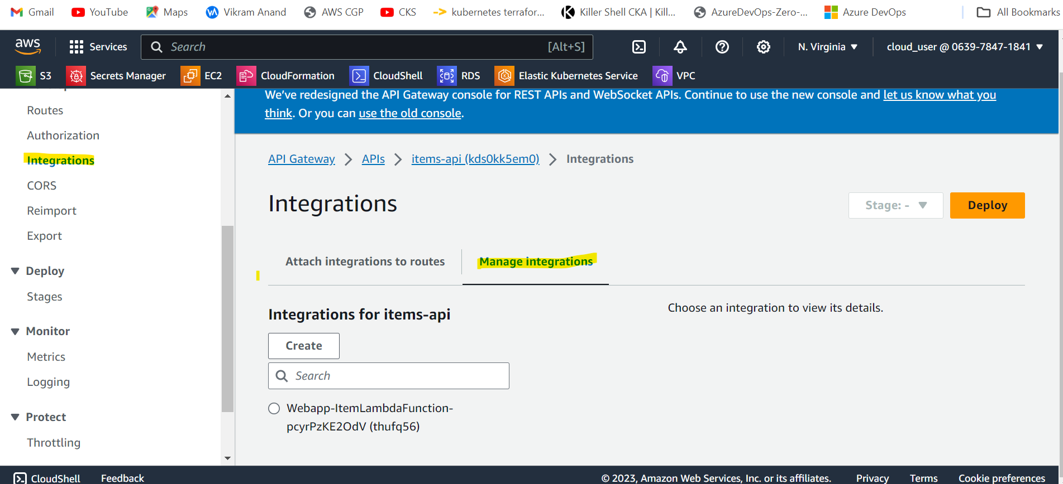

We create a new integration for Lambda function

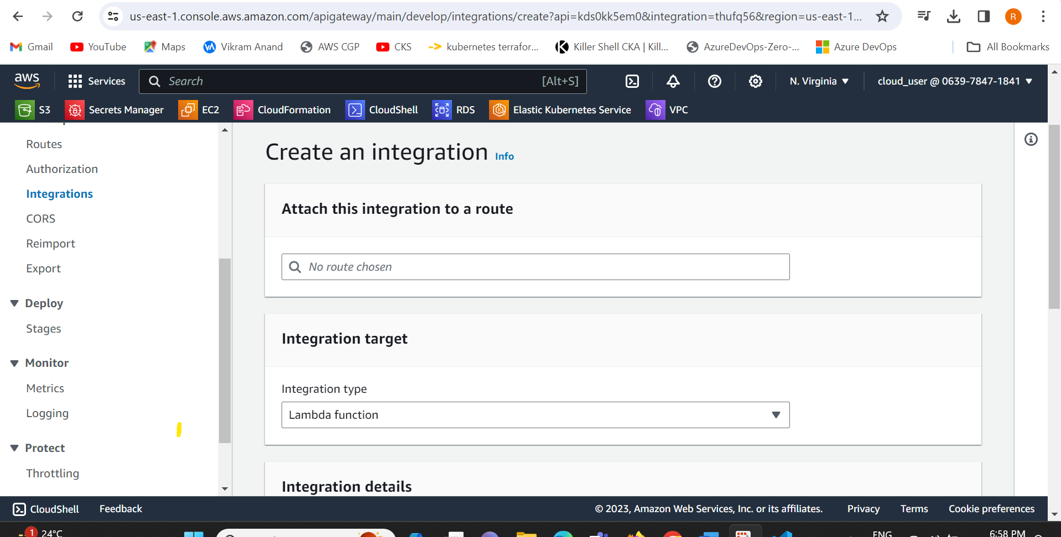

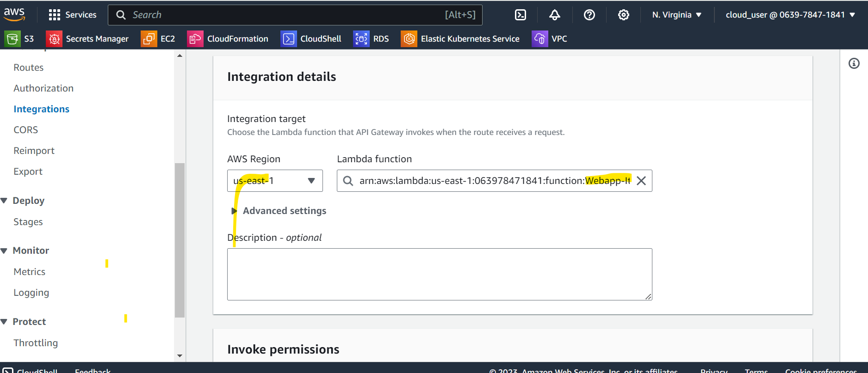

Integration ID

9kx8z5l

Now we create all the methods for our API gateway.

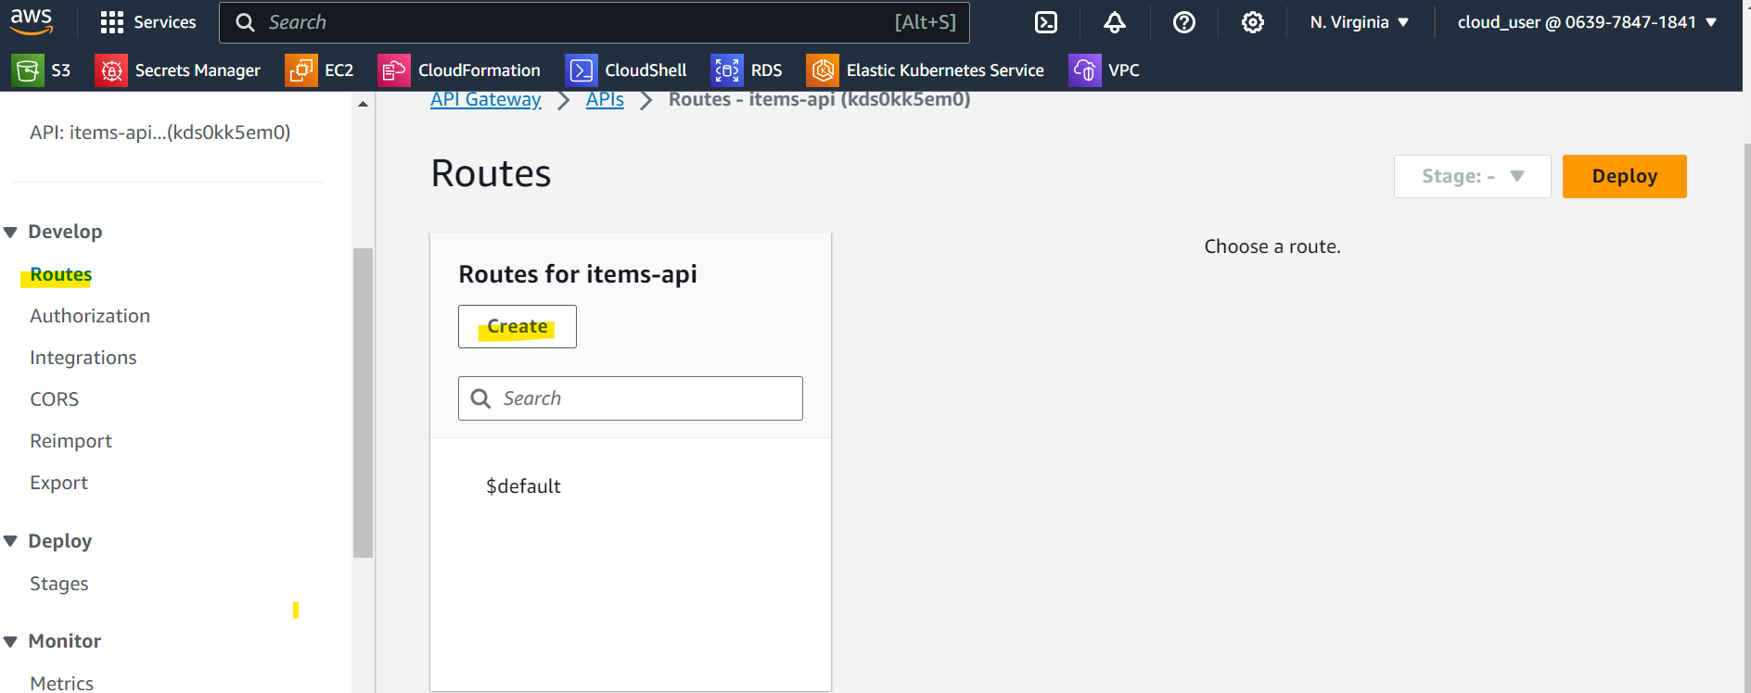

Now attach each METHOD type with lambda integration

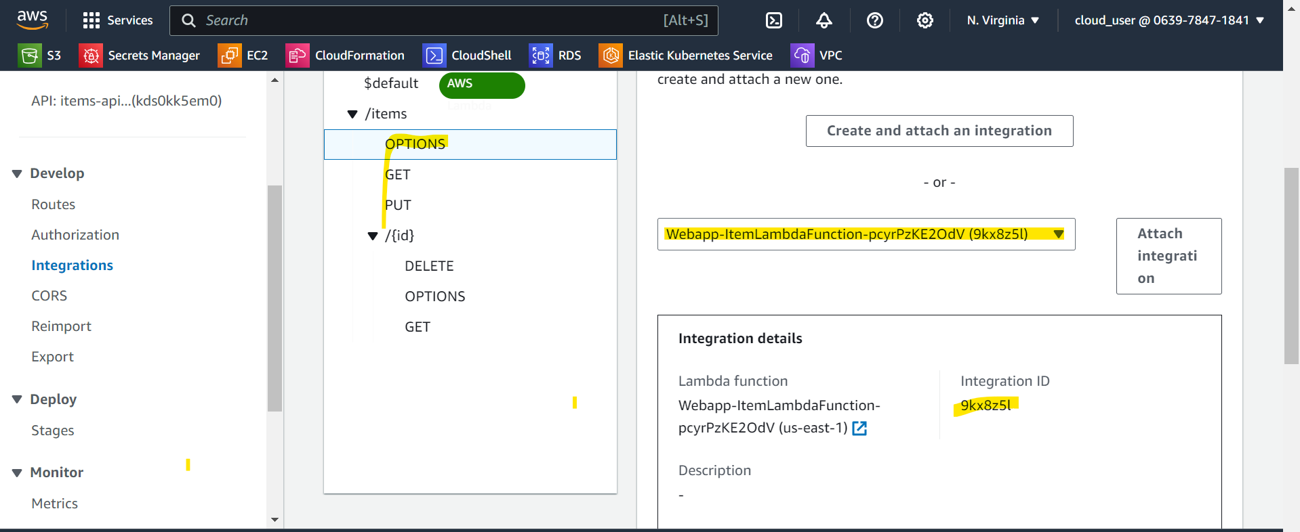

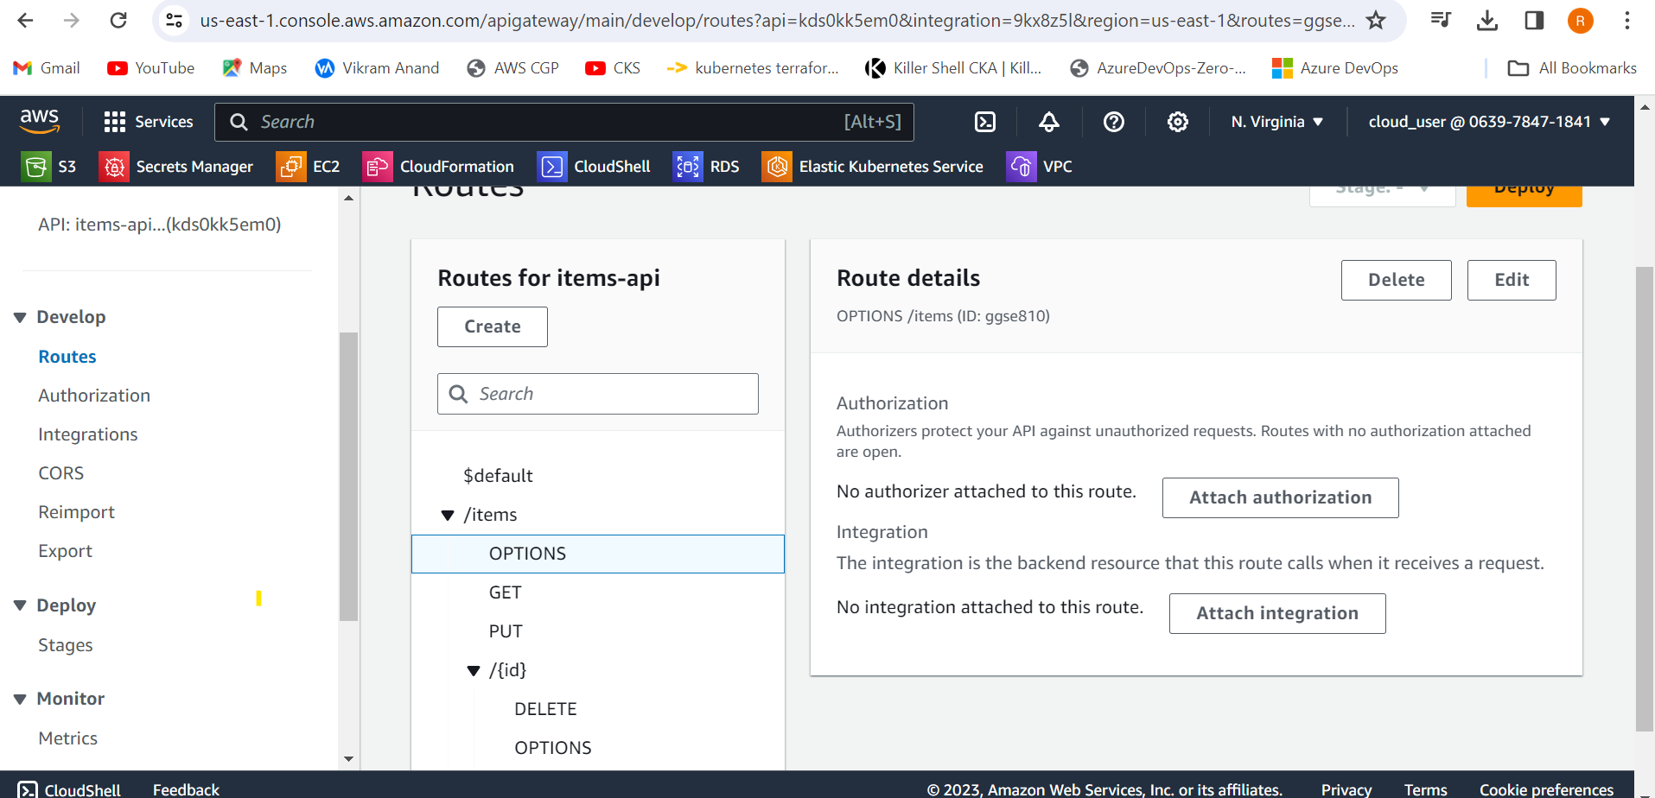

Now we go to the path from windows and install npm

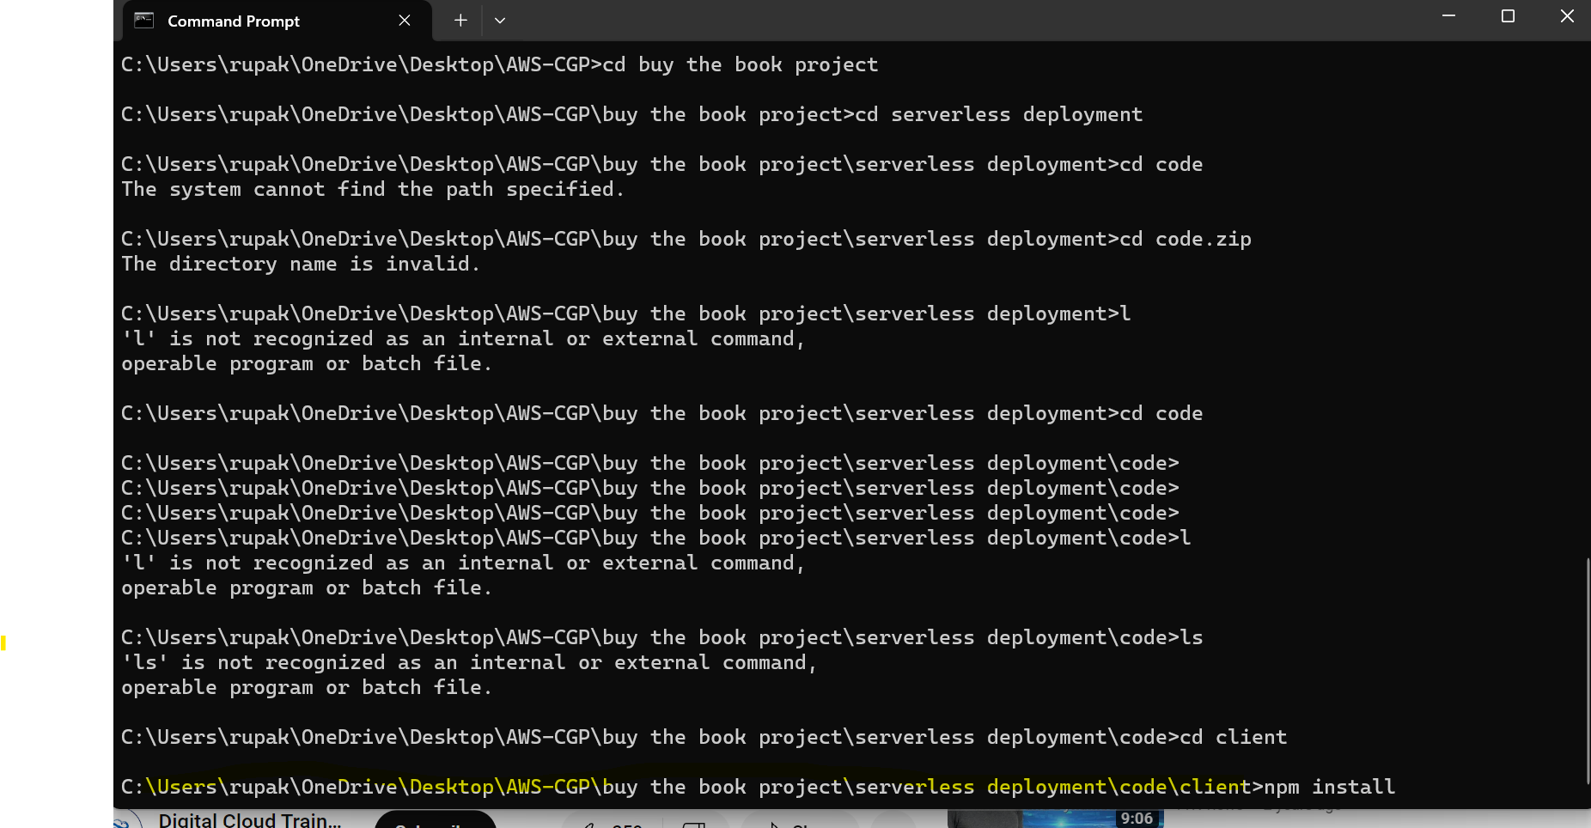

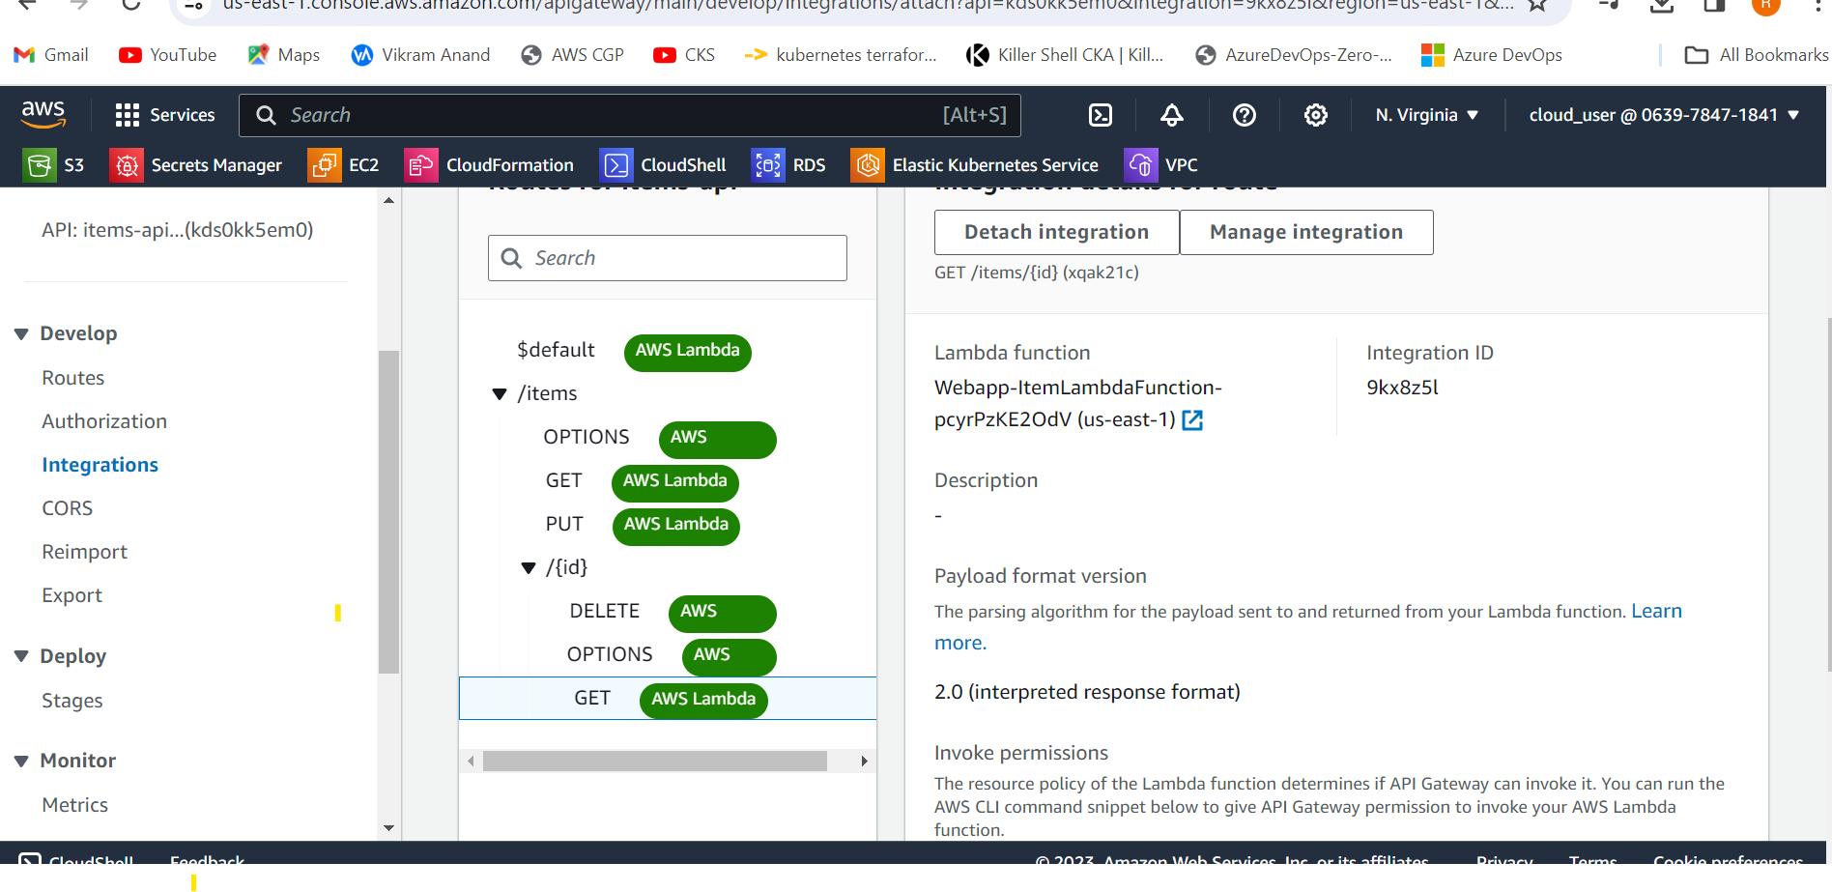

Now we have to integrate API Gaateway with S3.

Now we go to s3 and bucket name and copy the name

[item-frontend-static-hosting-4545](https://s3.console.aws.amazon.com/s3/buckets/item-frontend-static-hosting-4545?region=us-east-1)

 https:// [item-frontend-static-hosting-4545](https://s3.console.aws.amazon.com/s3/buckets/item-frontend-static-hosting-4545?region=us-east-1).s3.amazonaws.com

.s3.amazonaws.com

Again we go to API gateway and CORS

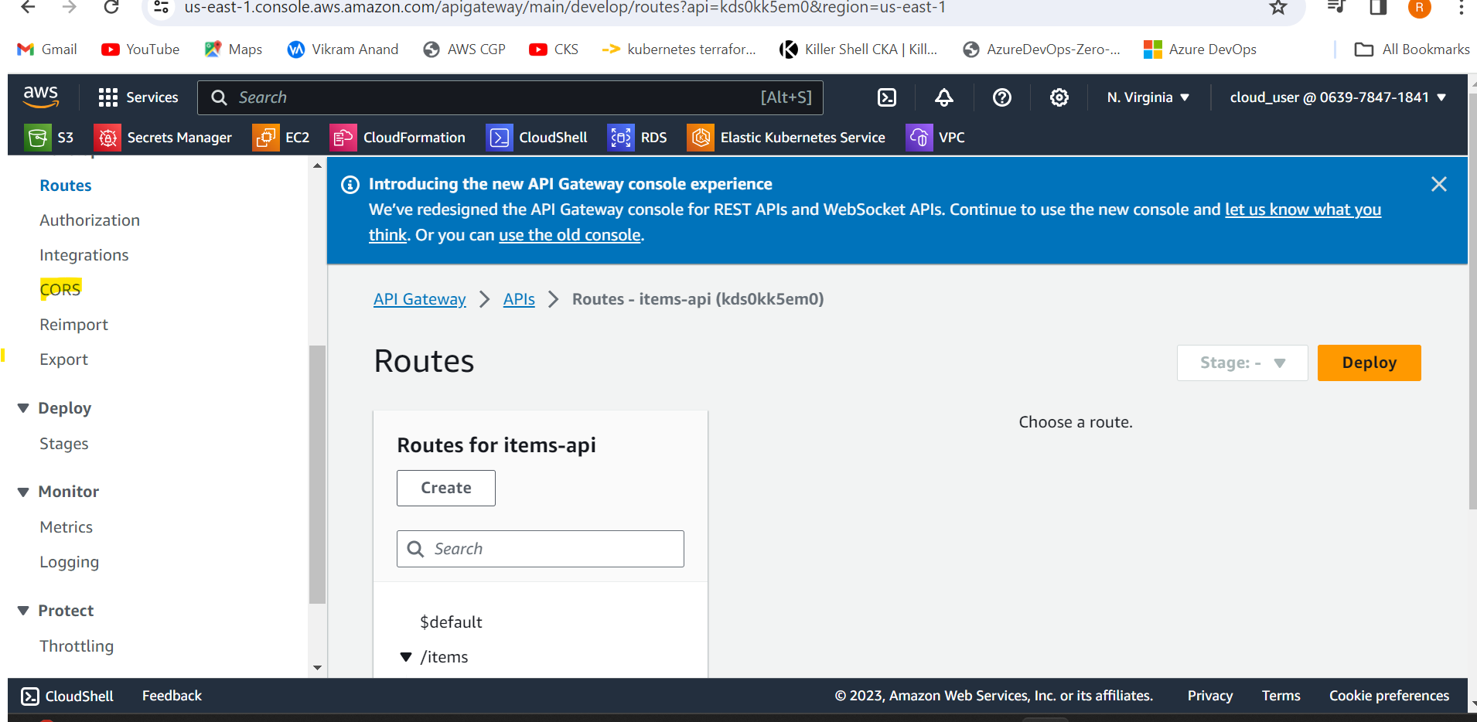

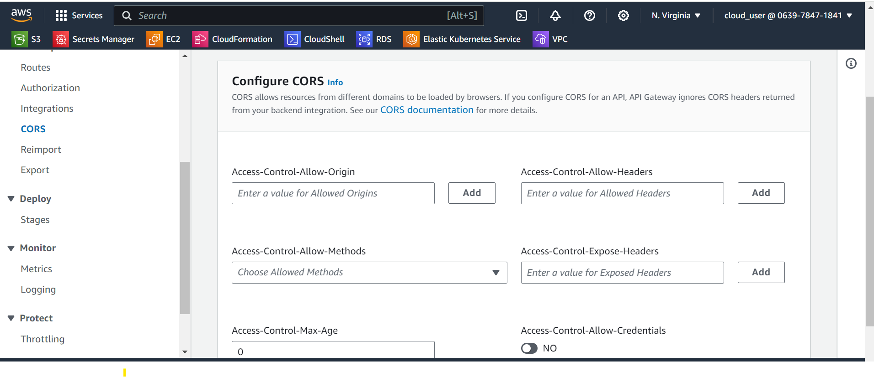

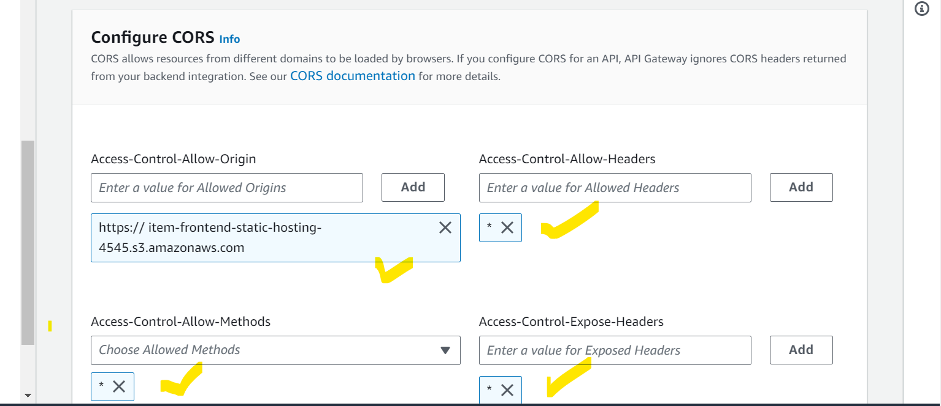

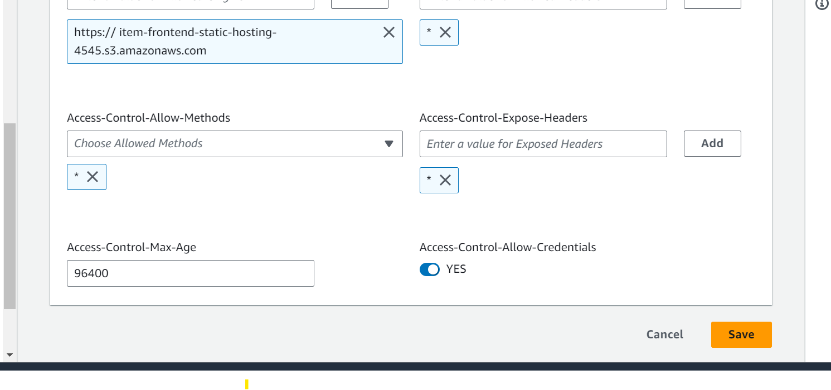

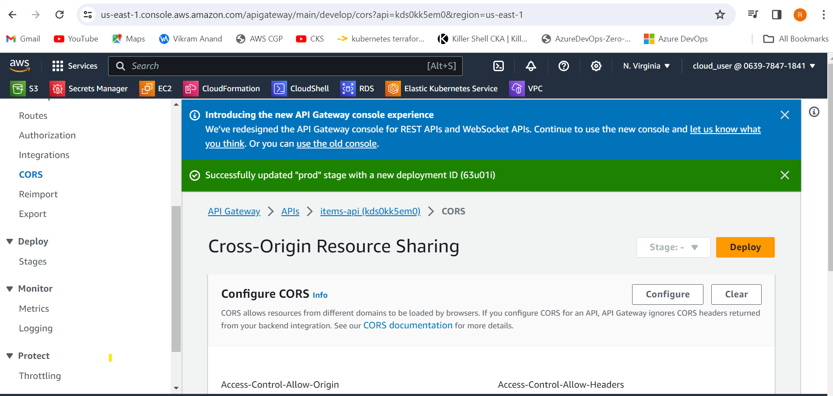

Note the invoke URL

<https://kds0kk5em0.execute-api.us-east-1.amazonaws.com/prod>

Next we go to command promopt and go to the path .

Then we install npm install in the directory path

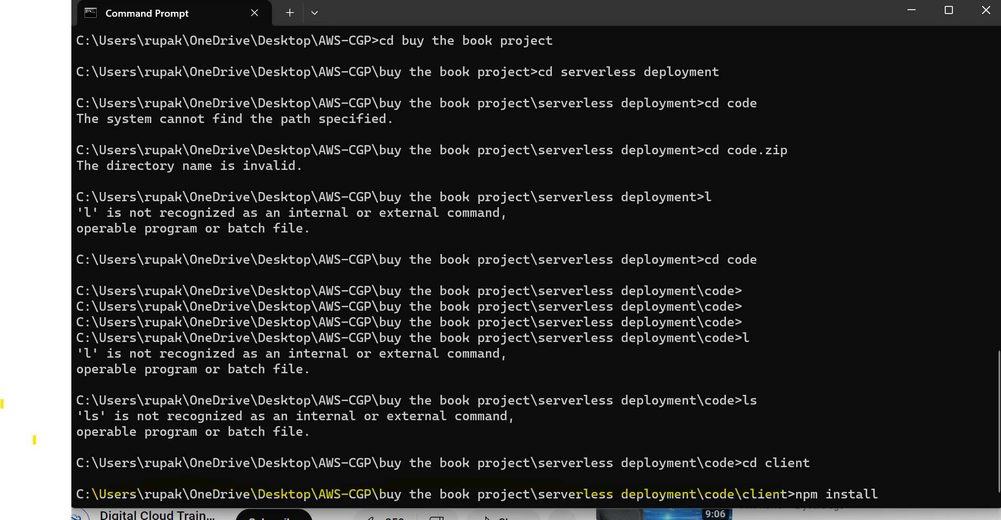

Then npm run build

This will create a build folder in our local with all the files which we will upload in s3.

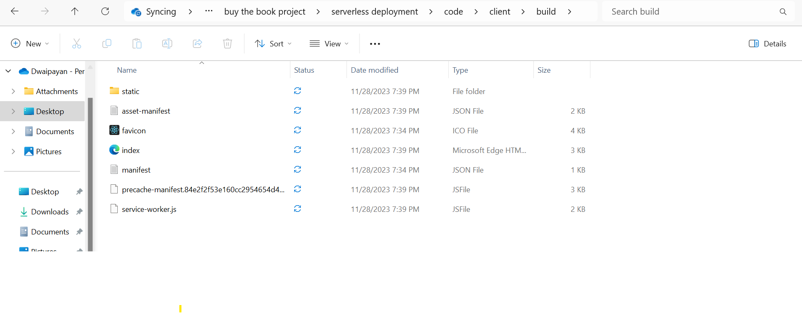

Then we select the index.html object and get the url

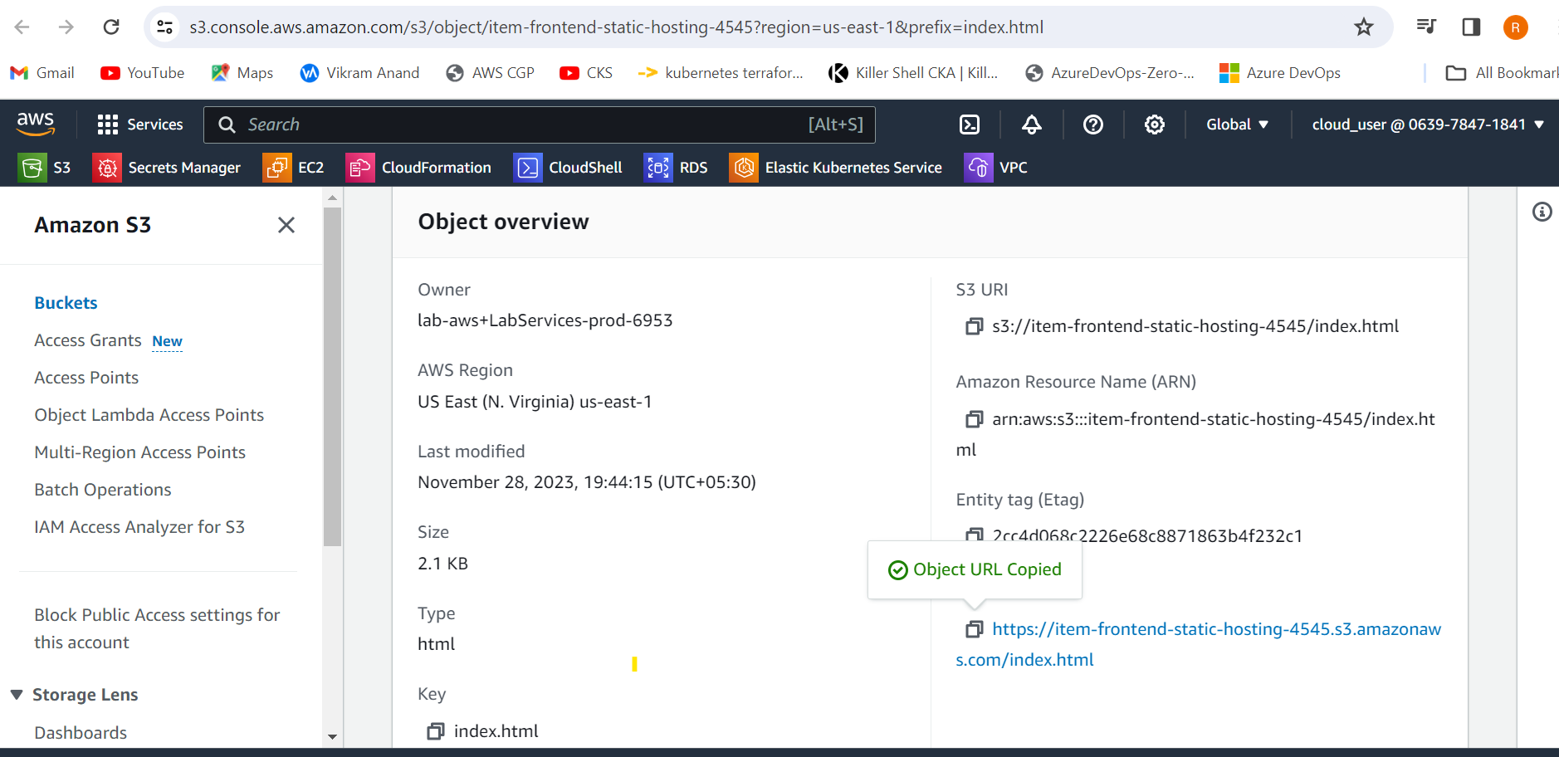

And hit in browser.

